This kit provides you with 3 letter templates to send to the debt collector and the credit bureaus. Each letter needs to be edited and adjusted to your circumstance. Delete any parts that don’t apply to you.

Send “**Letter 1”** as soon as you can– if possible, within 30 days of receipt of a letter from a debt collector. It’s important that you do this quickly, because under the FDCPA, your legal rights to obtain verification information from a debt collector are greater during the 30-day period.

Remember: If someone is asking you to pay money, you are entitled to ask for details.

There are ultimately 3 different outcomes from sending these letters:

1. **The debt is validated & not on your credit report yet.**
   1. Negotiate a lower total payment with the debt collector. Get confirmation that this won’t appear on your credit report in the future. Pay the debt.
2. **You receive no response from the debt collector.**
   1. Send “NO RESPONSE - LETTER 2” to the debt collector and “NO RESPONSE - LETTER 3” to the credit bureaus until the account is removed.
3. **The debt is validated & already on your credit report.** 
   1. Get in contact with the debt collector and ask if they will remove the account from your credit report once the debt is paid.

**\*Even if you have not received anything in the mail regarding this collection account, send the letters anyway. Use the account number that is listed on your credit report.**

**TIMELINE:** 2-5 months

**THE OBJECTIVE:** To have the collection agency send you proof that they are now legally collecting this debt

**THE PROOF:** A copy of the original bill

**IF NO RESPONSE:** Send “NO RESPONSE - LETTER 2”

**IF NO RESPONSE AFTER LETTER 2:** [File a complaint with the CFPB](https://www.consumerfinance.gov/complaint/) and send “NO RESPONSE - LETTER 3” to the credit bureaus

**IF NO DELETION FROM CREDIT REPORT:** Send “NO RESPONSE - LETTER 3” to the credit bureaus again

**IMPORTANT:** These letters are meant for COLLECTIONS. This is not meant to be sent to the original creditor. The original creditor will obviously be able to provide proof that you owe the debt, as the original contract was between you and them. This kit is meant for accounts that are now in collections.

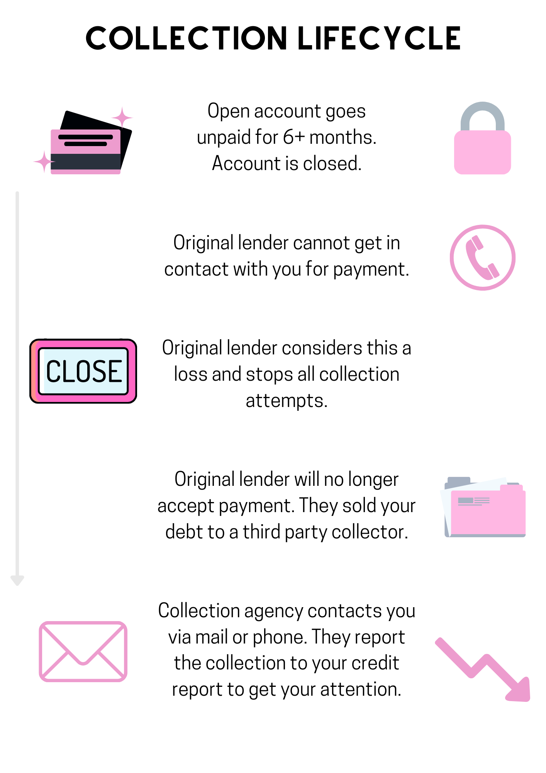

**FIRST ATTEMPT - LETTER 1**

**Your Name**

**Your Address**

**Debt Collector  
Debt Collector Address**

**Date**

**Account Number:**

To whom it may concern:

I am sending this letter to you in response to **[an account I see on my credit report OR a letter I received in the mail]** on **[DATE].** In this letter you claim I owe debt to **[ORIGINAL CREDITOR].**

This is not a refusal to pay, this is a debt validation request for the above referenced account.

I am requesting that your office provide me with factual evidence that I have a legal obligation to pay you. Please provide me with the following:

* Who the money you say I owe is for
* A copy of the last billing statement sent to me by the original creditor
* If there have been any additional interest, fees, or charges added since the last billing statement from the original creditor, provide an itemization showing the dates and amount of each added amount
* Prove the Statute of Limitations has not expired on this account;
* Provide your debt collection license numbers and registered agent contact information.

Please also know that by way of this letter I am requesting that no telephone or email contact be made by your office to my home, to my place of employment, or my mobile phone. All future communications with me MUST be done in writing and sent to the address noted in this letter.

Kind Regards,

**Full Name, NO SIGNATURE**

**NO RESPONSE - LETTER 2**

**Your Name**

**Your Address**

**Debt Collector  
Debt Collector Address**

**Date**

**Account Number:**

To whom it may concern:

I am sending a follow up letter to the original letter I sent on **[DATE]**. In that letter, I requested debt validation for an account that is on my credit report. It has now been 45 days since I sent that original letter. You are now in violation of the FDCPA

This is not a refusal to pay, this is a debt validation request for the above referenced account.

I am requesting that your office provide me with factual evidence that I have a legal obligation to pay you. Please provide me with the following:

* Who the money you say I owe is for
* A copy of the last billing statement sent to me by the original creditor
* If there have been any additional interest, fees, or charges added since the last billing statement from the original creditor, provide an itemization showing the dates and amount of each added amount
* Prove the Statute of Limitations has not expired on this account;
* Provide your debt collection license numbers and registered agent contact information.

Please also know that by way of this letter I am requesting that no telephone or email contact be made by your office to my home, to my place of employment, or my mobile phone. All future communications with me MUST be done in writing and sent to the address noted in this letter.

Kind Regards,

**Full Name, NO SIGNATURE**

**NO RESPONSE - LETTER 3**

**Your Name**

**Your Address**

**Credit Bureau**

**Credit Bureau Address**

**Date**

To whom it may concern:

I recently reviewed my credit report and found an account on there that I did not recognize:

Account Name:

Account Number:

On **[DATE**],I sent a letter directly to **[COLLECTOR NAME]**, requesting that they validate the debt and provide me with evidence that I owe them that debt.

I did not receive a response from my initial letter sent on **[DATE]**, and so I sent a second letter on **[DATE].** I still have not received a response from them.

I am requesting that you remove the reporting of this collection from my credit report. I do not know what this account is or why it is listed under my credit.

Unless you are able to validate this account directly with the debt collector, I expect this account to be removed immediately. I intend to report this collection to the CFPB as well if this is not resolved.

Thank you in advance,

**Full Name, NO SIGNATURE**

**Credit Bureau Mailing Addresses:**

Transunion

PO Box 2000

Chester, PA 19016

Experian

PO Box 9701

Allen, TX 75013

Equifax

PO Box 740256

Atlanta, GA 30374

**Pull Your Credit Report -** [**$1 7-Day Trial**](https://www.identityiq.com/securepreferred.aspx?offercode=43125540)

**Sending Certified Mail -** [**TikTok Walkthrough**](https://www.tiktok.com/@tatianacredit/video/7014243788604411142?is_from_webapp=1&sender_device=pc&web_id7039012949201110534)

**Credit Theory Service -** [**Credit Repair Consultation**](https://calendly.com/credittheory/consultation)

**Join for Collection & Credit Support -** [**Credit Theory Facebook Group**](https://www.facebook.com/groups/450709422998775/)